Module 9 – Working with Calculations and Expressions in Tableau

9.1 Calculation Syntax and Functions in Tableau
What are Calculations?
Calculations allow you to create new fields from existing data.
Examples:
- Profit Ratio
- Discount Percentage
- Yearly Sales
- Customer Categories

Tableau Calculation Syntax
Basic Syntax
SUM([Sales])
Arithmetic Operations
[Sales] - [Profit]
([Profit]/[Sales])*100
IF Statement
IF [Sales] > 1000 THEN "High"
ELSE "Low"
END

Steps to Create a Calculation
- Open Tableau.
- Right-click Data Pane.
- Click Create Calculated Field.
- Enter formula.
- Click OK.
Example
Profit Ratio = [Profit]/[Sales]

Visual Example
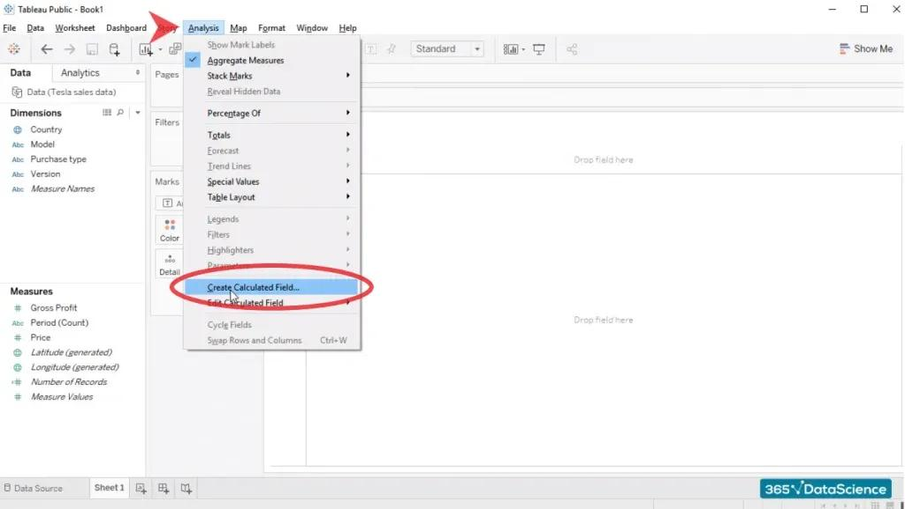
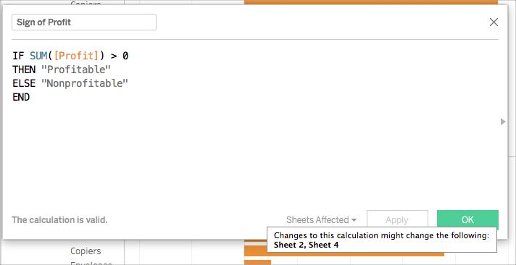
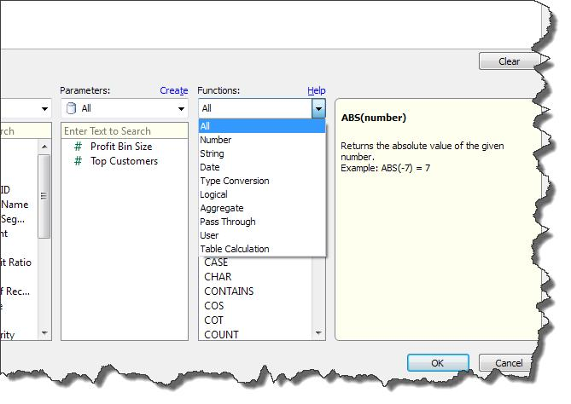
9.2 Types of Calculations in Tableau

A. String Calculations
Used for text manipulation.
Common Functions
Function | Example
LEFT | LEFT([Name],3)
RIGHT | RIGHT([Name],2)
LEN | LEN([Name])
UPPER | UPPER([Name])
LOWER | LOWER([Name])
Example
UPPER([Customer Name])
Converts text to uppercase.
Image
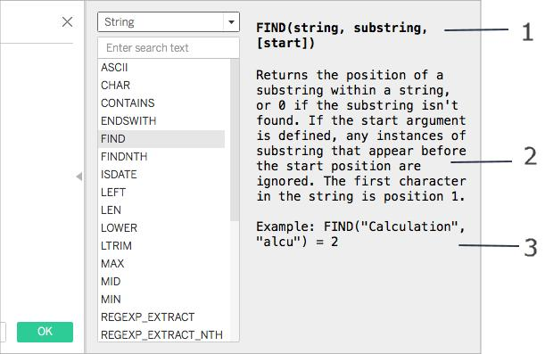
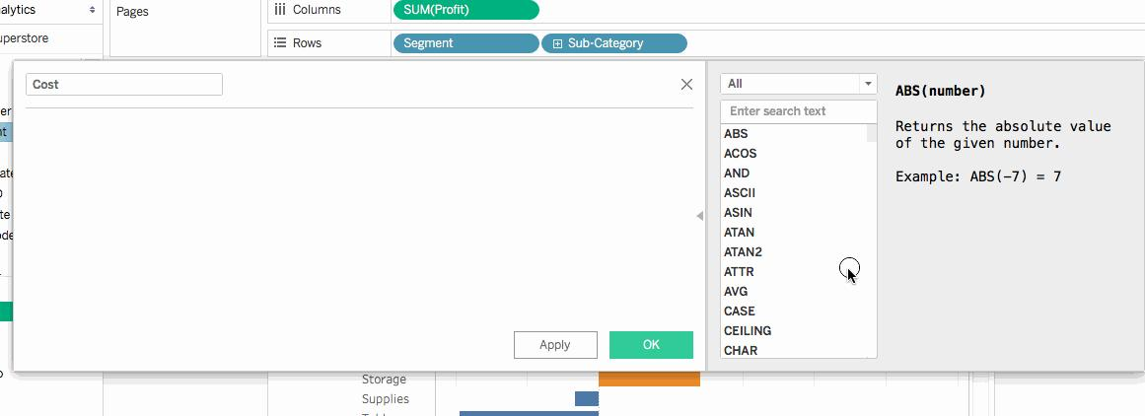


B. Number Calculations
Used for mathematical operations.
Example
[Sales]-[Profit]
Functions
ABS()
ROUND()
SQRT()
POWER()
Example
ROUND([Sales],2)

C. Date Calculations
Used to analyze time-based data.
Functions
YEAR()
MONTH()
DAY()
DATENAME()
DATEADD()
DATEDIFF()
Example
DATEADD('month',3,[Order Date])
Adds 3 months.
Image
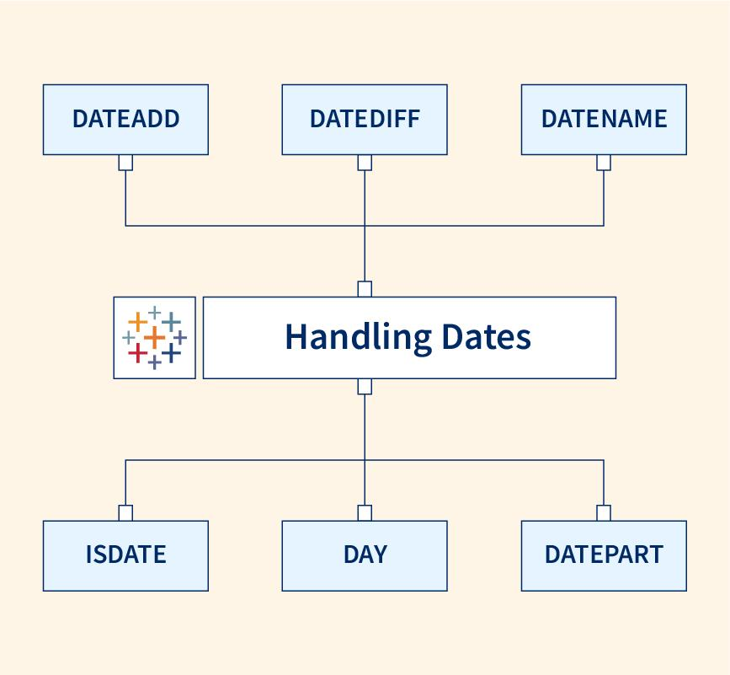
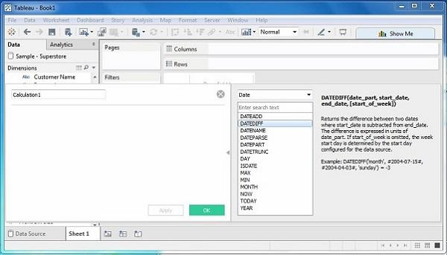
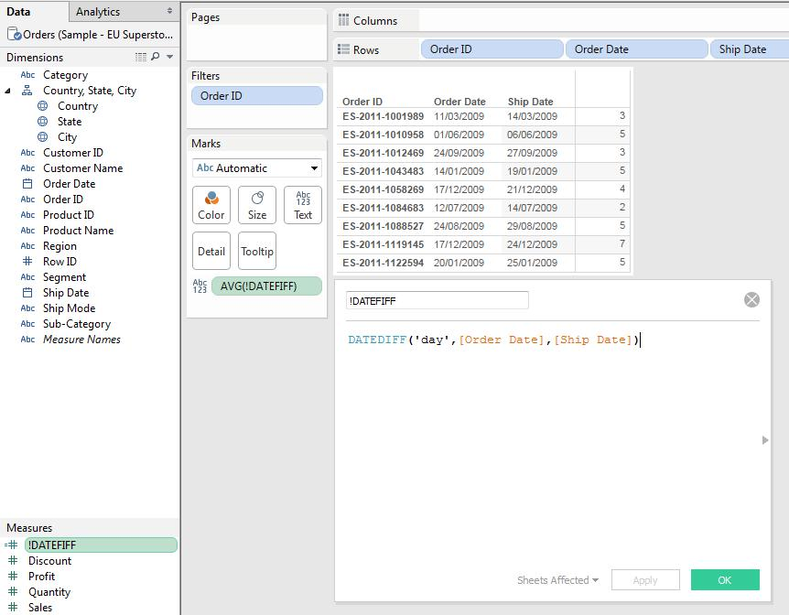
D. Aggregate Calculations
Used to summarize data.
Functions
SUM()
AVG()
MIN()
MAX()
COUNT()
Example
AVG([Sales])
Image
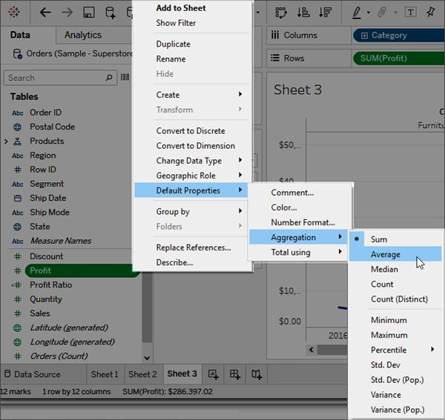
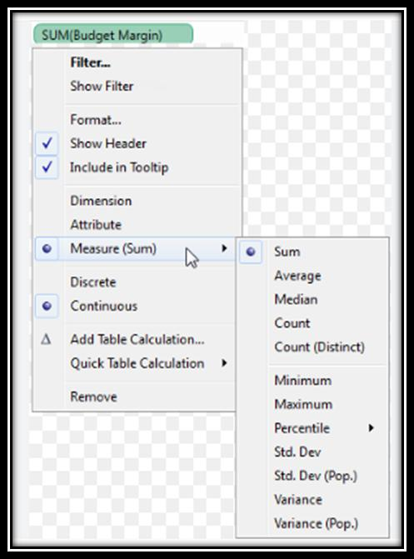
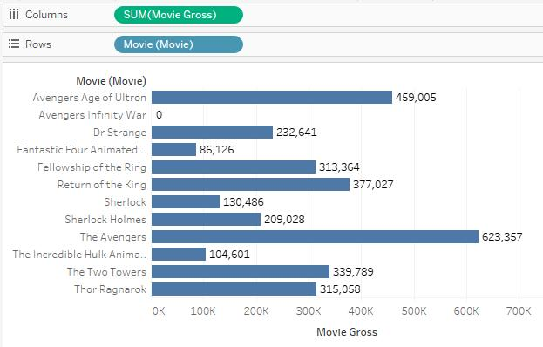

E. Logical Calculations
Used for conditions.
IF Statement
IF [Profit] > 0 THEN "Profit"
ELSE "Loss"
END
CASE Statement
CASE [Category]
WHEN "Furniture" THEN 1
WHEN "Technology" THEN 2
END
Image

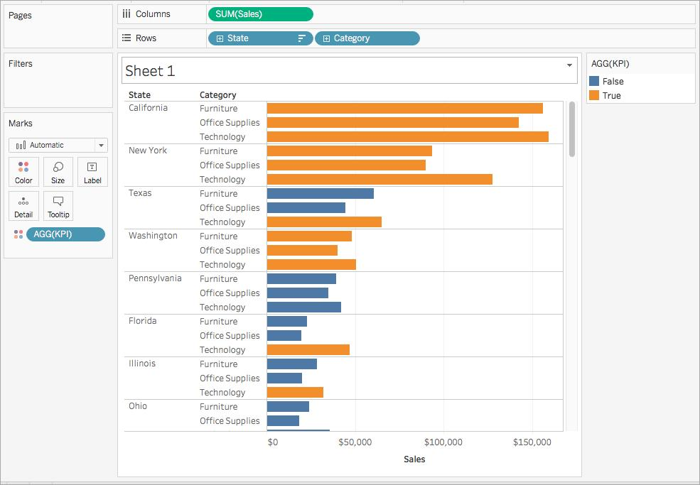
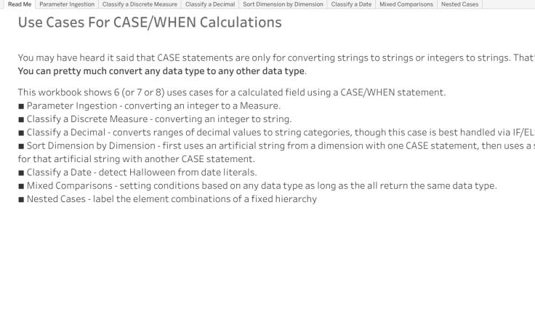
F. Table Calculations
Performed after Tableau aggregates data.
Examples:
- Running Total
- Moving Average
- Rank
- Percent of Total
Example
RUNNING_SUM(SUM([Sales]))
Steps
- Drag Sales.
- Right-click Sales.
- Quick Table Calculation.
- Running Total.
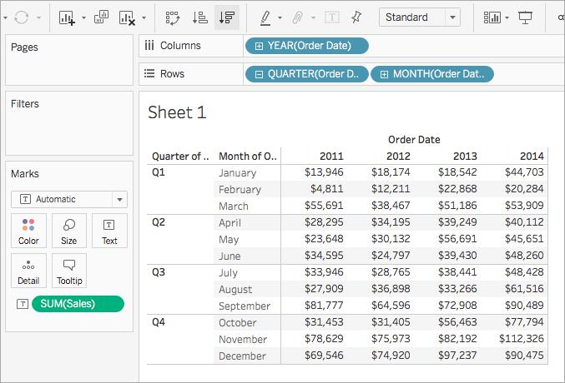
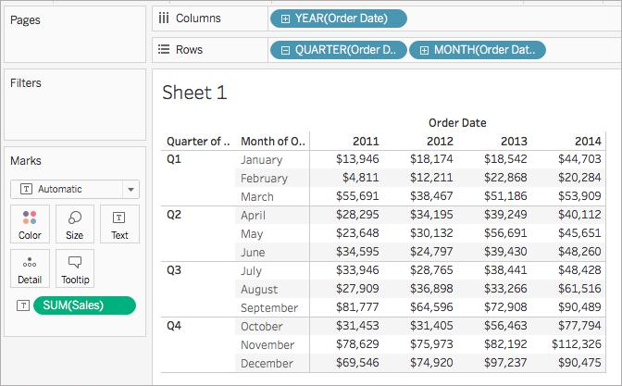
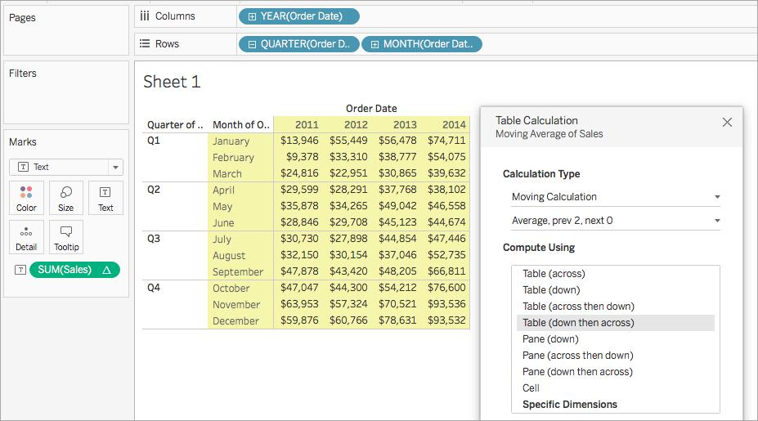

9.3 Level of Detail (LOD) Expressions

What is LOD (Level of Detail)?
LOD expressions allow calculations at different levels of granularity regardless of visualization level.

Types of LOD
1. FIXED LOD
Calculates independent of view.
Syntax
{ FIXED [Region] : SUM([Sales]) }
Meaning
Calculate total sales for each Region.
Steps
- Create Calculated Field.
- Enter FIXED expression.
- Drag into visualization.
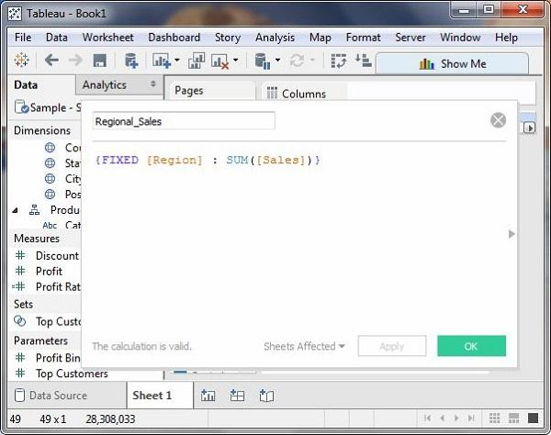
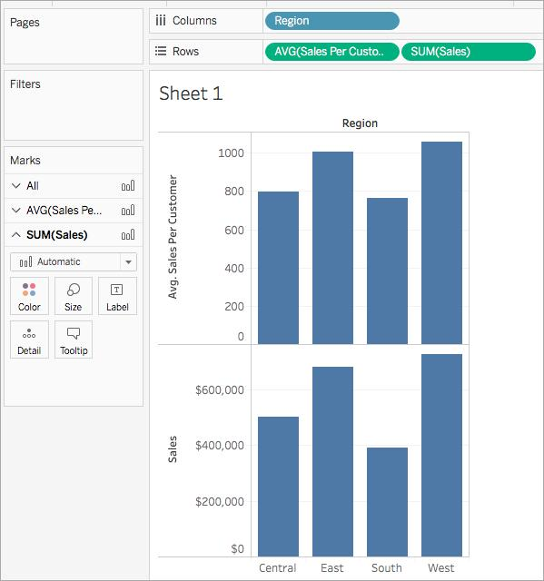

{ FIXED : SUM(IF [Sub-Category] = "Tables" THEN [Sales] END) }

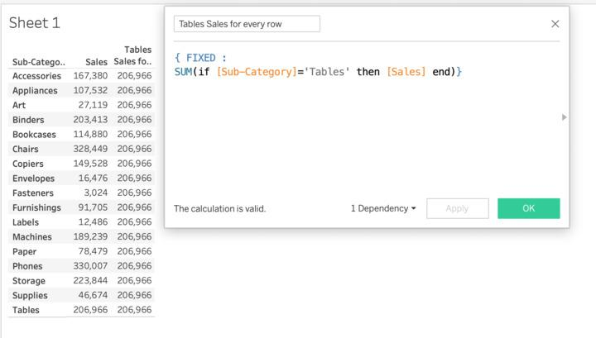

2. INCLUDE LOD(Level of Detail) (Lower Level)
Adds more detail.
Syntax
{ INCLUDE [Customer Name] : SUM([Sales]) }
Meaning
Calculate sales including Customer level.
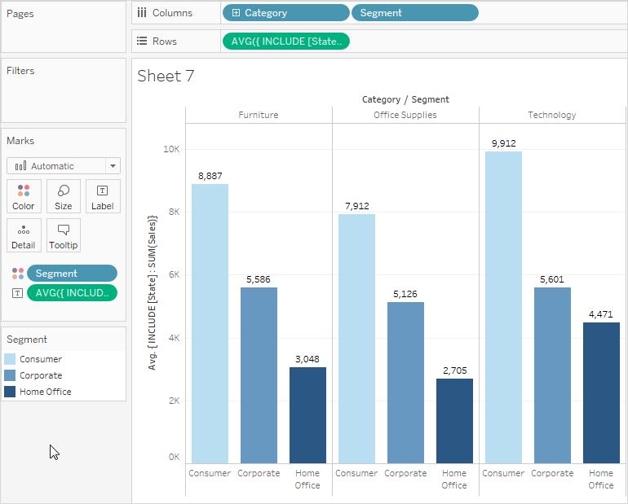
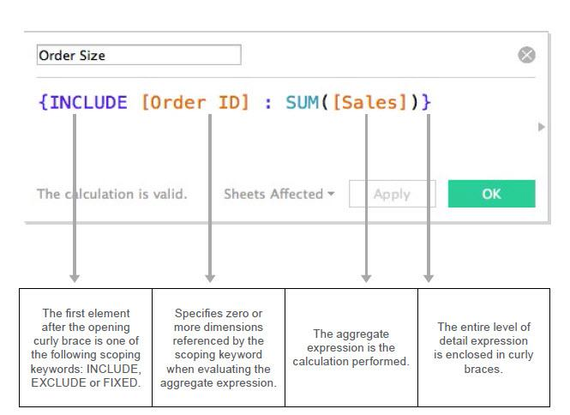
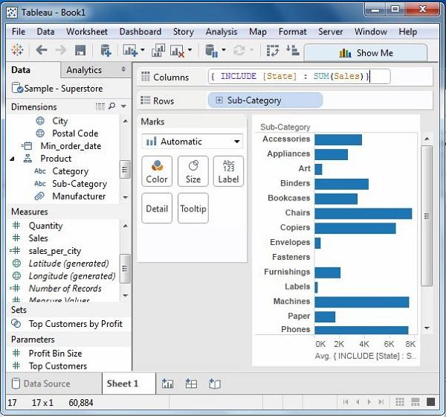

3. EXCLUDE LOD (Higher Level)
Removes detail.
Syntax
{ EXCLUDE [Sub-Category] : SUM([Sales]) }
Meaning
Ignore Sub-Category while calculating.
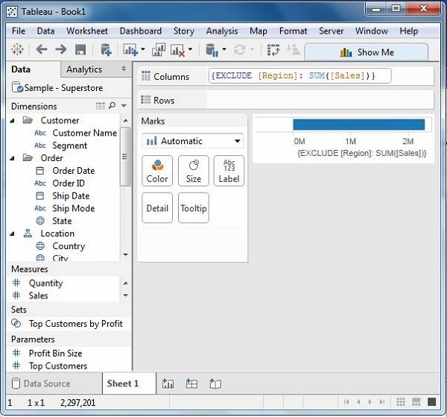
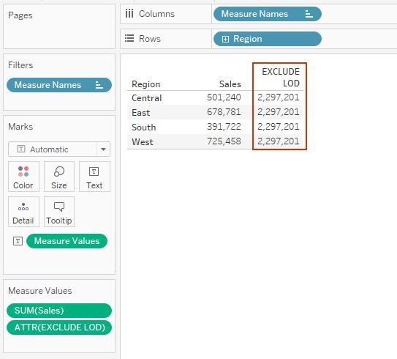
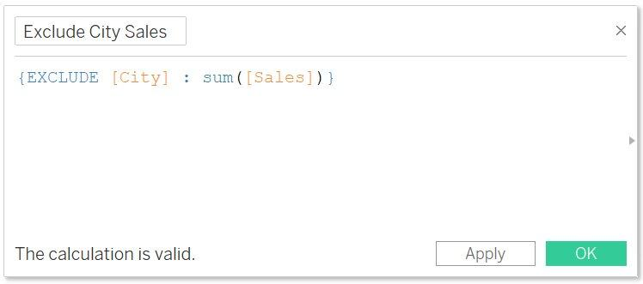

LOD Expression Syntax
General Form:
{
FIXED/INCLUDE/EXCLUDE
[Dimension]
:
Aggregation
}
Example:
{ FIXED [Region] : AVG([Sales]) }

Nested LOD Expressions
LOD inside another LOD.
Example
{ FIXED [Region] :
AVG(
{ FIXED [Customer Name] :
SUM([Sales])
}
)
}
Use Case
Average customer sales within each region.

Aggregation and Replication with LOD
Aggregation
Returns summarized values.
Example:
{ FIXED [Region] : SUM([Sales]) }

Replication
Same value repeats for all rows in region.
Customer | Region | Region-Sales
Amit | East | 50000
Raj | East | 50000
Neha | East | 50000
This is called replication.

9.4 Quick Table Calculations

What are Quick Table Calculations?
Prebuilt calculations available without writing formulas.

Available Options
Calculation
Running Total
Difference
Percent Difference
Percent of Total
Rank
Moving Average
YTD Total
Compound Growth Rate

Steps
- Add Measure.
- Right-click Measure.
- Quick Table Calculation.
- Select required calculation.
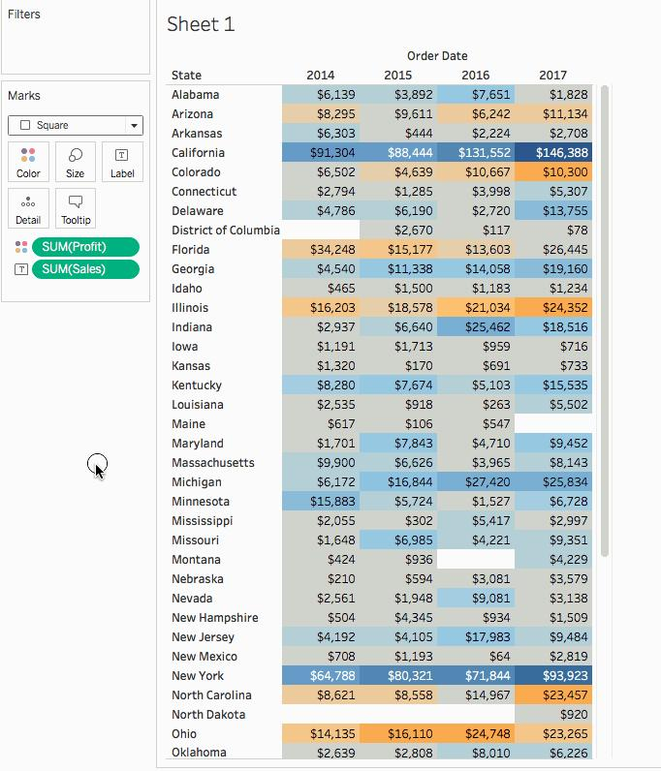
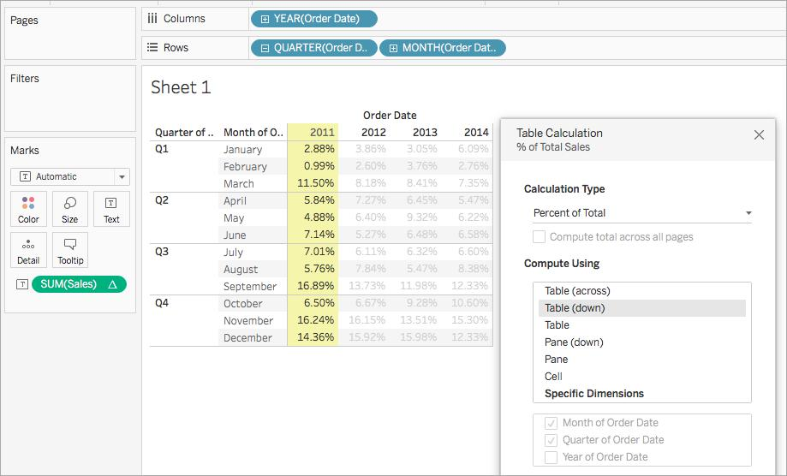
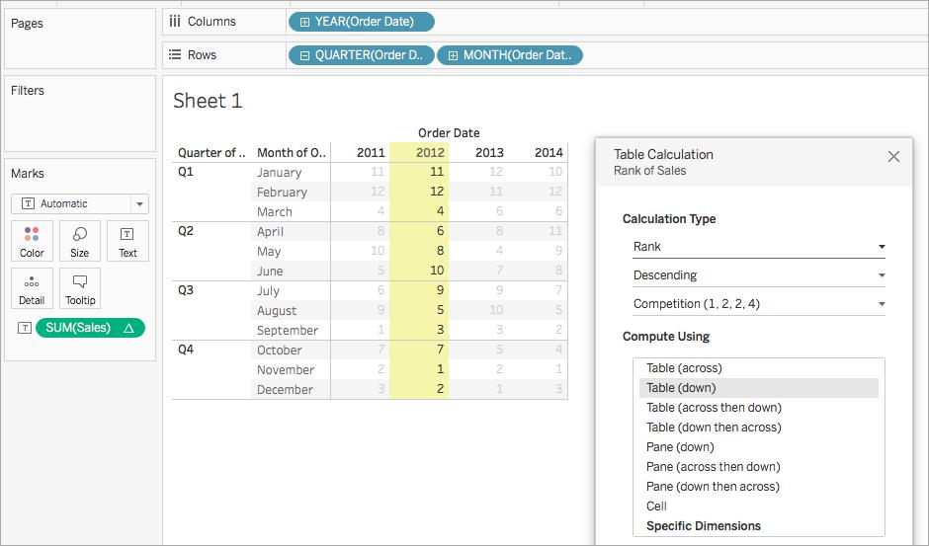

9.5 Creating Calculated Fields

Steps
Step 1
Data Pane → Right Click
Step 2
Create Calculated Field
Step 3
Enter Name
Example:
Profit Margin
Step 4
Write Formula
([Profit]/[Sales])*100
Step 5
Click OK
New field appears in Data Pane.

Practical Examples
Profit Margin
([Profit]/[Sales])*100
Sales Category
IF [Sales] > 10000 THEN "High Sales"
ELSE "Low Sales"
END
Year Extraction
YEAR([Order Date])


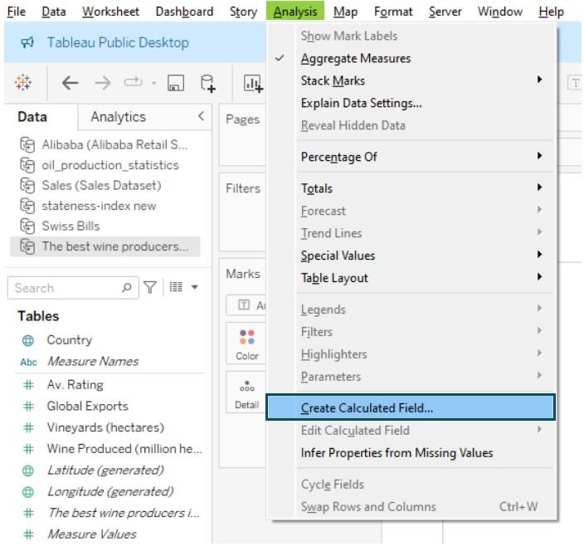


9.6 Quick LODs
What are Quick LODs?
Tableau can automatically generate LOD expressions without writing syntax.

Steps to Create Quick LOD
Method 1
- Select a Dimension.
- Right-click.
- Choose Create → LOD Expression.

Method 2 (Drag Method)
- Drag Measure onto Dimension.
- Tableau creates FIXED LOD automatically.

Example
Dimension:
Region
Measure:
Sales
Generated LOD:
{ FIXED [Region] : SUM([Sales]) }

Benefits of Quick LOD
✔ Faster development
✔ No need to remember syntax
✔ Reduces errors
✔ Useful for dashboards



